Website address: <http://www.comparefirst.sg>

**Scenario 1: TL 20Y 45 M** *(Term Life – 20 Years policy – 45 Years age – Male)*

Parameters:

* Category: Term Life
* Date of Birth: 01/07/1973 (DD/MM/YYYY)
* Gender: Male
* Smoker: No
* Premium Type: Annual
* Coverage Term: 20 Years
* Sum Assured: 400,000
* Critical Illness: No
* Sort Results by: Insurer (A-Z)

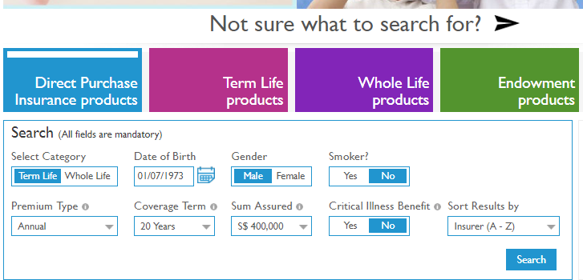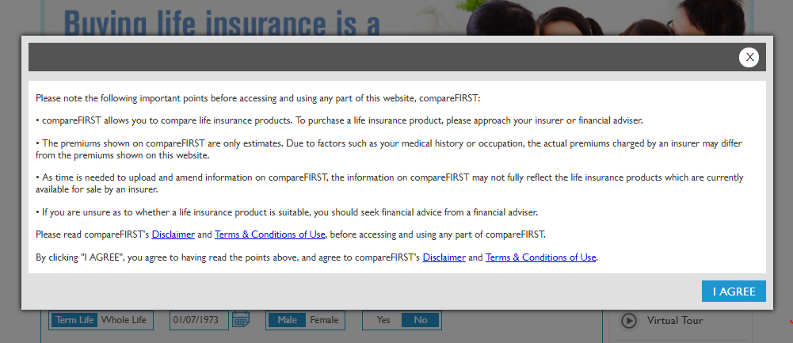

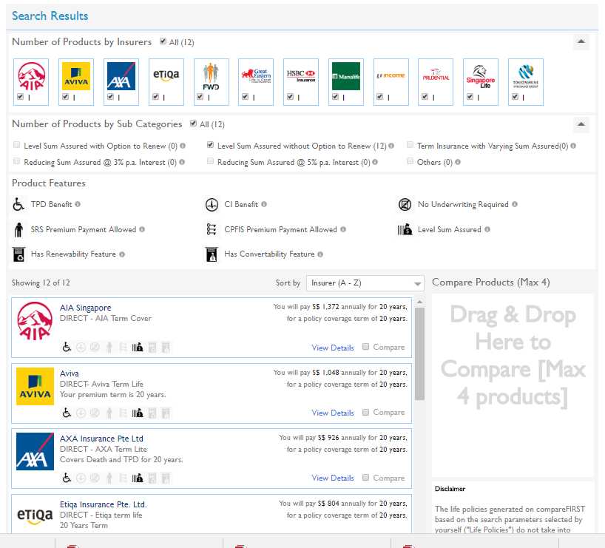

**Output File**

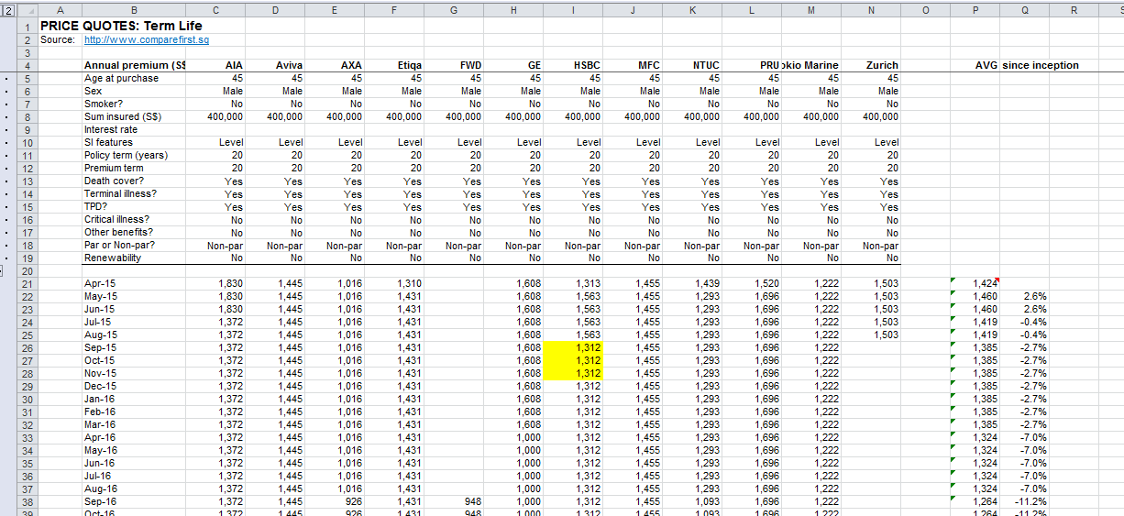

* o   TL 20Y 45F
* o   TL 5Y 45M
* o   TL 5Y 45F
* o   TL 20Y 30M
* o   TL 20Y 30F
* o   TL 20Y 45M CI
* o   WL 25P 45M
* o   WL 25P 45M (2)
* o   WL 25P 45F
* o   WL 40P 30M
* o   WL 40P 30F
* o   WL 40P 45M
* o   WL 25P 45M CI